## Create Tagging (Diagram 3.1 Version 1.0 11/24/2015)

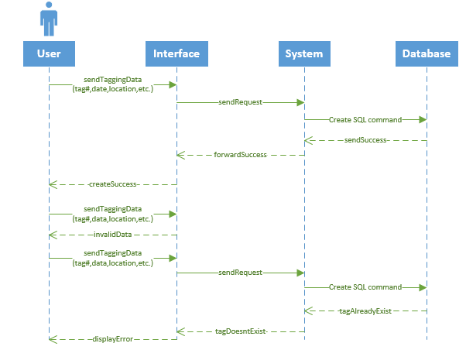

## Create sighting (Diagram 3.2 Version 1.0 11/24/2015)

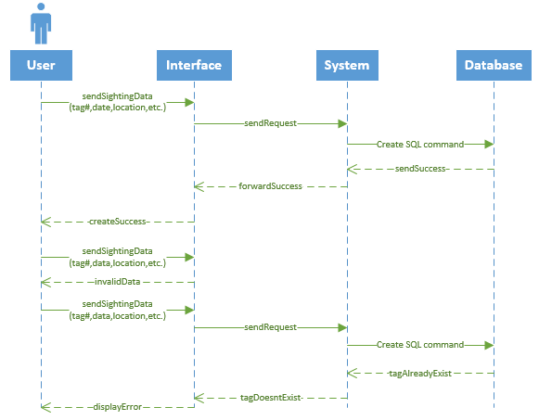

1. **Upload Batch file (Diagram 3.3 Version 1.0 11/24/2015)**

